**Tableau- Assignment 8**

1. You can do calculations on the data values in your fields using number functions. Only fields with numerical values can be used with number functions. With the help of a dataset of your own choice, illustrate the use of the string functions CEILING(number) and FLOOR(number). Mention your inferences from the illustration.

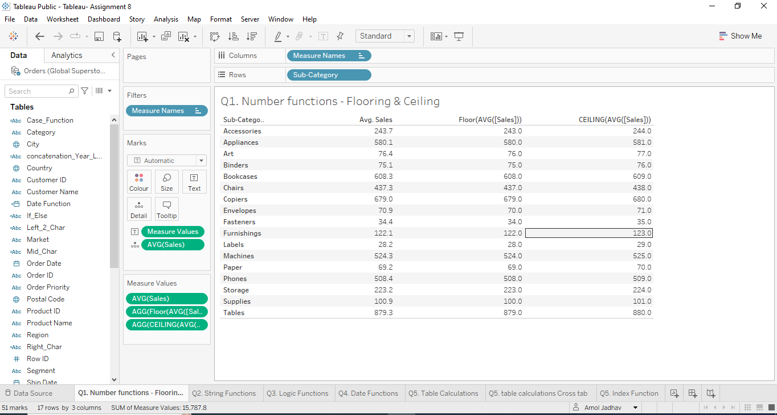

1. Tableau has a number of string methods to make dealing with strings possible. With the help of a dataset of your own choice, illustrate the use of the string functions- concatenation, Left() and Find(). Mention your inferences from the illustration.

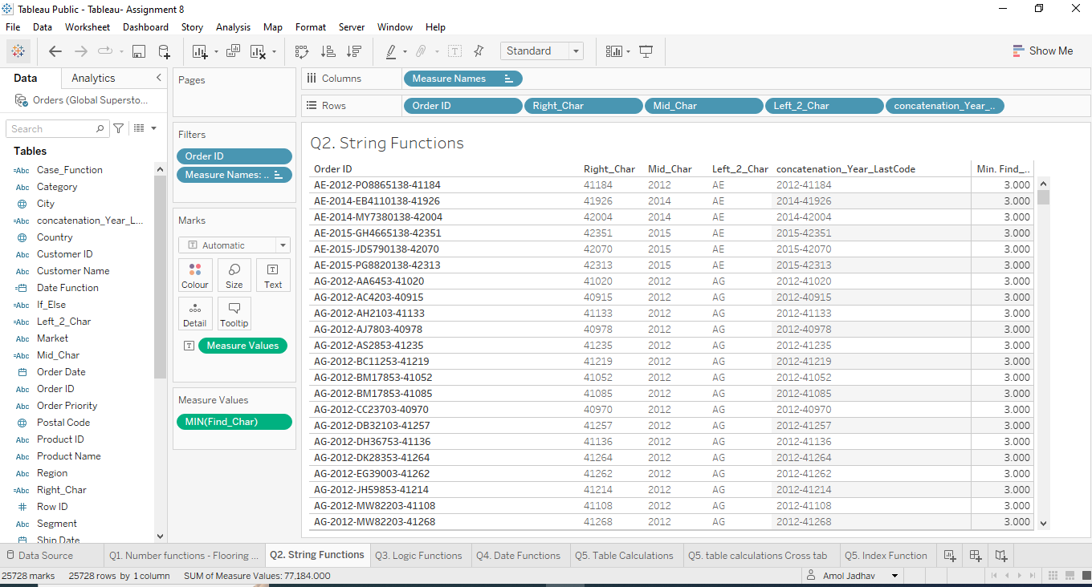

1. Tableau has a number of logical methods to make dealing with strings possible. With the help of a dataset of your own choice, illustrate the use of the logic functions- CASE() and IF ELSE(). Mention your inferences from the illustration.

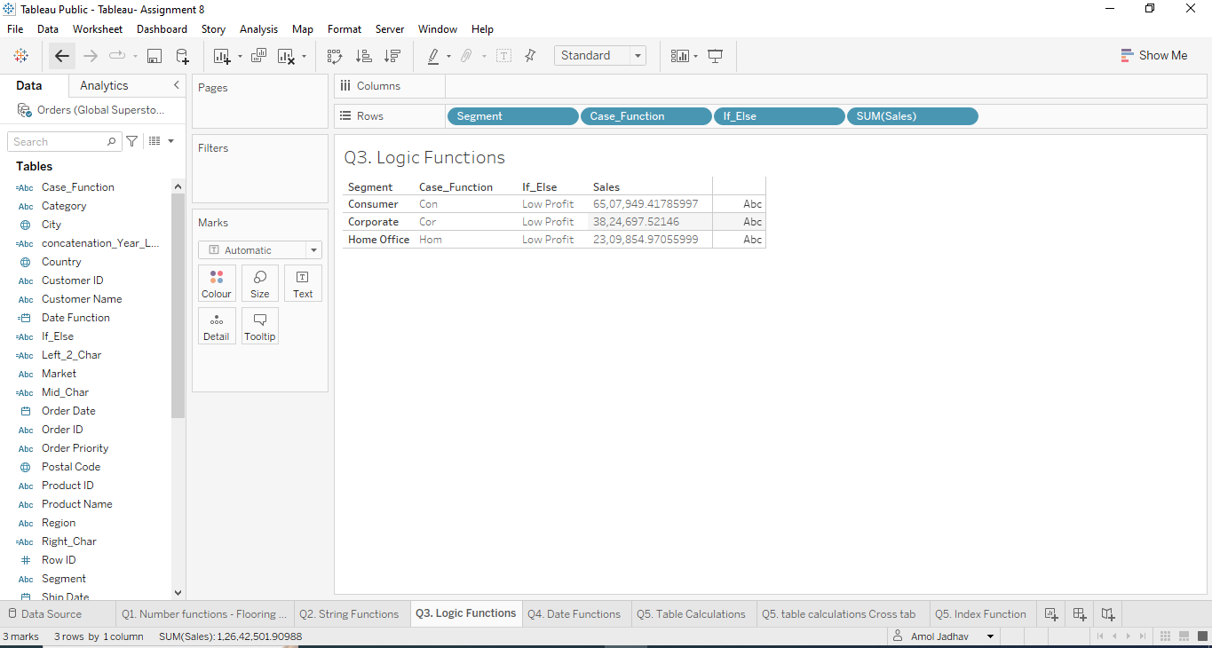

1. Tableau has a number of date methods to make dealing with dates possible. With the help of a dataset of your own choice, illustrate the use of the datefunctions- DATEDIFF() and DATE(). Mention your inferences from the illustration.

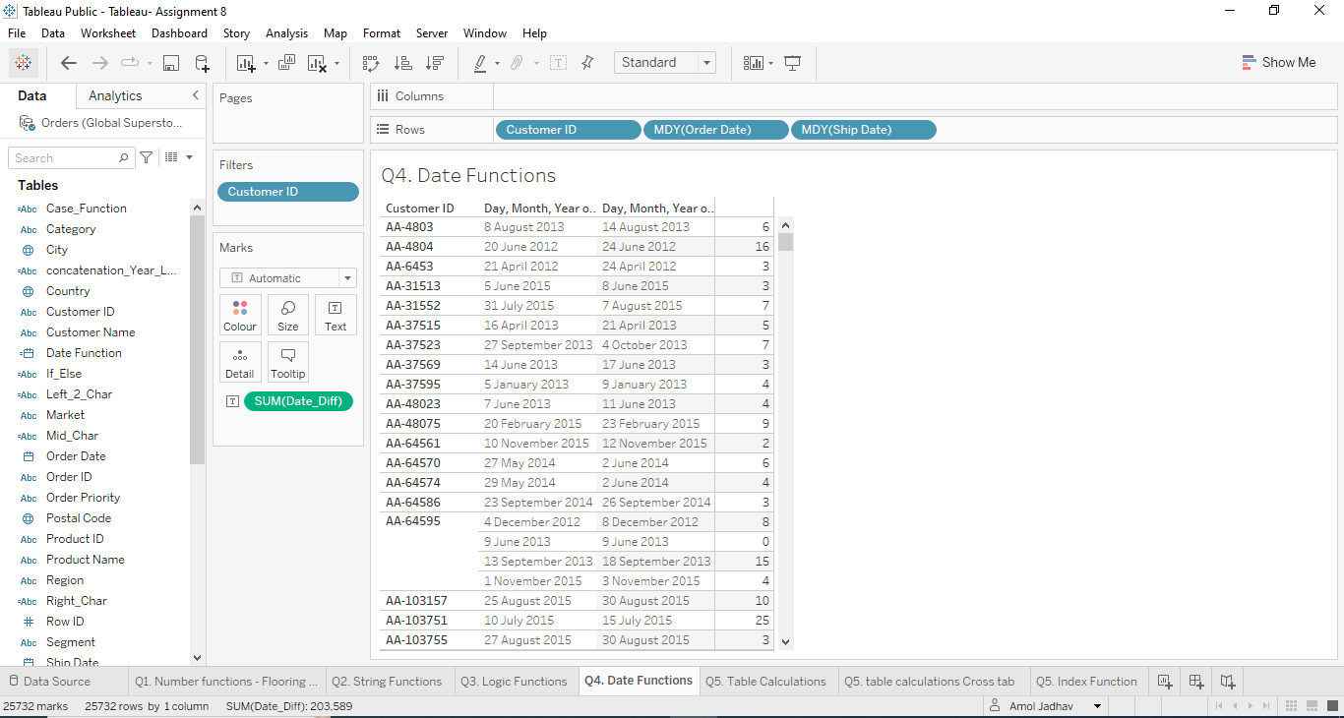

1. Calculations that are performed on a whole table are called table calculations. Table computations basically involve applying some sort of aggregation level to values that are returned from the database With the help of a dataset of your own choice, illustrate the use of the table calculations- First() and Index(). Mention your inferences from the illustration.

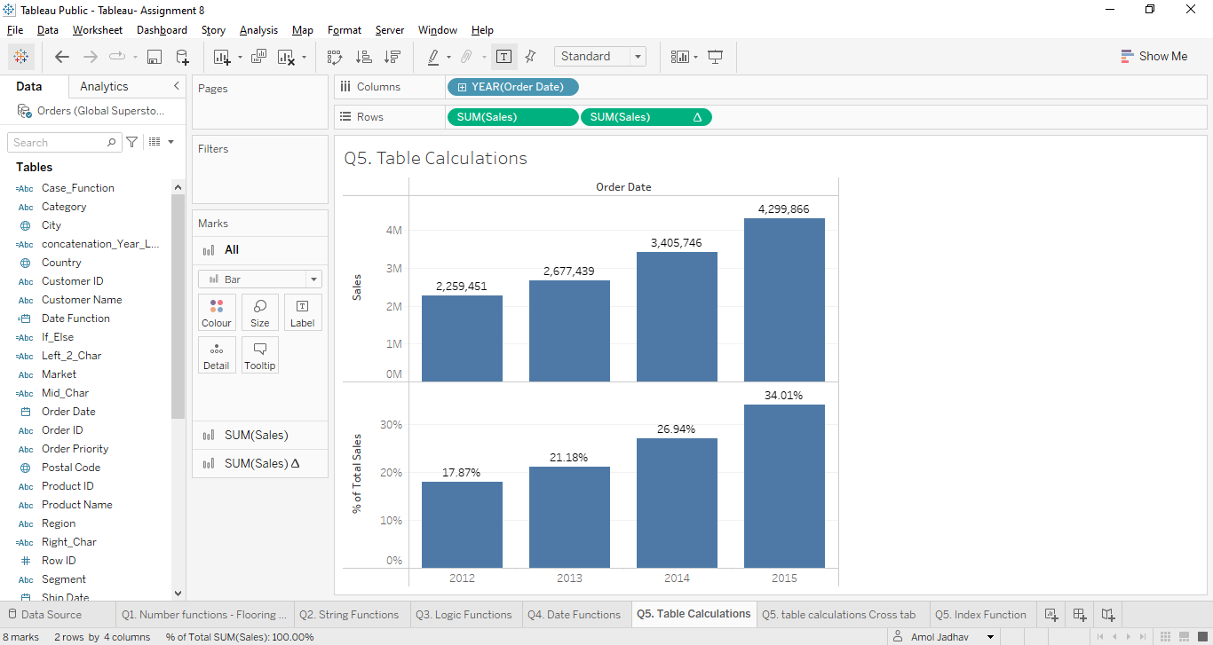

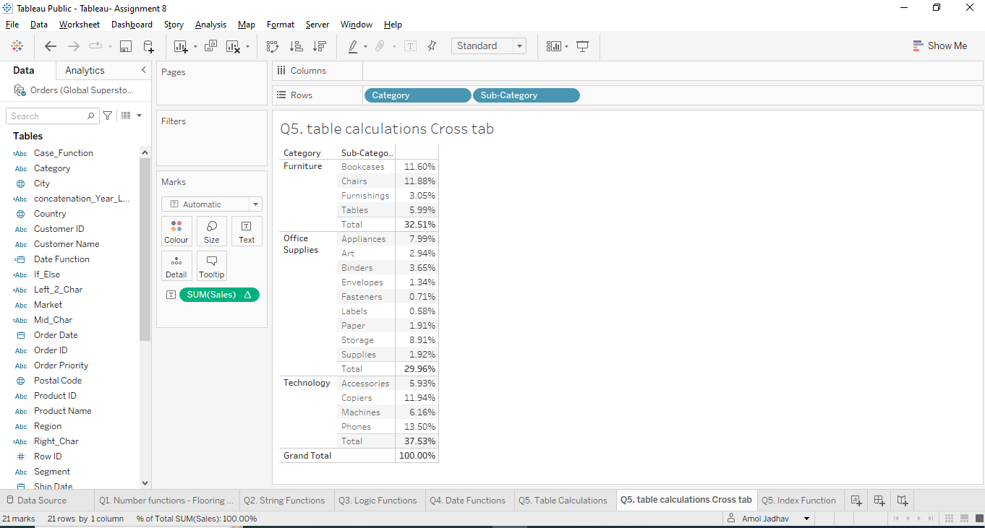

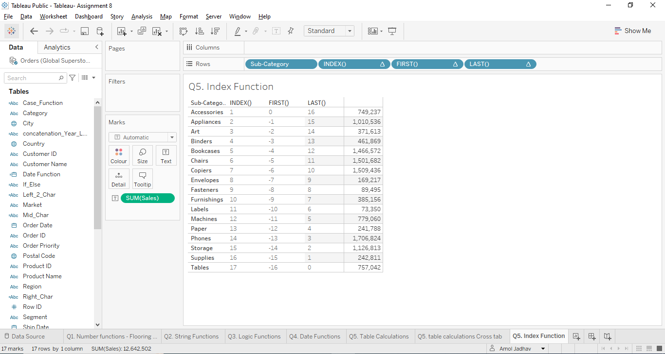

[*PFA links for the datasets used.*](https://drive.google.com/drive/folders/123UyMRbrReCjyn1K4g_FhsjKx6cP4zLH?usp=sharing)